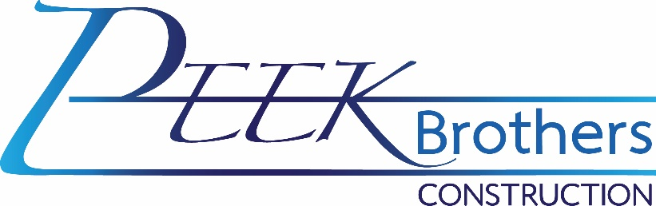
Water Truck Driver Class B – Full Time
The ideal candidate must be punctual, motivated, and willing to learn and develop their skills. Must also be detail-oriented, honest, and carry out tasks safely and professionally.

Class B Truck Driver will be a safety-minded and reliable driver, able to operate various tractors.

Qualifications:
- Must be able to pass a pre-employment DOT drug screen.
- Regular and timely attendance is an essential function of this position.
- Transportation to and from the yard.
- Ability to effectively communicate with employees and customers.
- 1+ years of experience driving a Class B Commercial vehicle with a manual transmission and tanker endorsements.
- A current medical card is required.

Preferred Qualifications:
- 3+ years of experience in the underground utility construction industry and horizontal construction field.
- Experience in dust control, excavation principles, underground utilities, and general construction site watering principles.

Duties and responsibilities:
- Perform pre-trip and post-trip daily inspections of truck and trailer.
- Keep accurate and detailed daily work log.
- Knowledge of USDOT and FMCSA safety regulations.
- Knowledge of local areas and the ability to understand maps and directions.
- Other duties as assigned.
Physical requirements:
- Must be able to perform the above for at least 8 hours per day, five days per week. May be required to work over-time, after-hours, on weekends, for emergencies, or on-call.
- Ability to work while wearing safety boots, safety glasses, and hardhat when required.
- Ability to work in adverse weather conditions, including extreme heat and cold temperatures, inclement weather such as wind, rain, snow, sleet, and dust, and adverse driving conditions including wet roads, icy roads, and fog.
- Employees in this job classification may be exposed to dust, fumes, or other airborne pathogens.
- Must be able to lift/carry 50 lbs. on occasion and up to 100 LBS as needed with or without assistance.

Benefits:
- Competitive pay
- Fully paid medical insurance for the employee, 50% paid medical for family.
- Vision and dental insurance available.
- 401K with up to 4% matching.
- Paid weekly
- Paid Time Off

