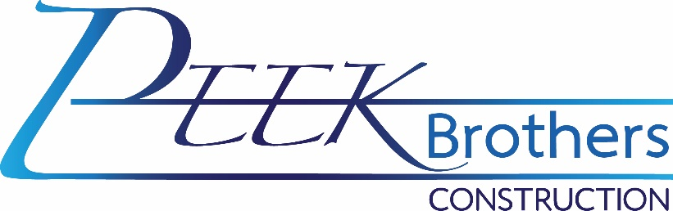
Fleet Mechanic – Full Time
The ideal candidate must be punctual, motivated, and willing to learn and develop their skills. Must also be detail-oriented, honest, and carry out tasks safely and professionally.
Performs journey-level maintenance, diagnosis, and repair of vehicles, trucks, and other company employees' equipment. Independent judgment is used to determine and perform repairs.

Qualifications:
- Must be able to pass a pre-employment drug screen.
- Two years of technical school, trade school, equivalent military training, and four years of hands-on experience in an automotive, heavy truck, or equipment maintenance/repair organization.
- Must have own hand tools.
- Functional knowledge of and ability to perform hands-on, in-depth diagnostics, electronic repair, mechanical repair, and fabrication on systems common to automobiles, heavy trucks, heavy equipment, and other miscellaneous vehicles and equipment.
- Will need to work independently to accomplish tasks.
- Has the aptitude to follow manufacturer recommendations and procedures.
- Need the necessary computer skills to operate various computer equipment and applications.
- Safely operate a variety of vehicles, maintenance, and repair equipment.
- Display an attitude of cooperation and work harmoniously with all levels of employees and the management.
- Communicate effectively in the English language at a level necessary for efficient job performance.
- Complete assignments in a timely fashion.
- Understand and comply with all rules, policies, and regulations.
- Maintain prompt and regular attendance.
- Perform all essential and marginal functions assigned by an authorized employee, supervisor, or Manager with or without reasonable accommodation.
- Some positions require the ability to obtain a; Class A or B Commercial Driver's License (CDL) with air brake, tanker, and combination endorsement; Mobile Air Conditioning Society (MACS) license for A/C recovery, recycling, and recharge.
- Individuals must be capable of operating vehicles safely and have an acceptable driving record.
Preferred Qualifications:
- 5+ years of hands-on combined experience in an automobile, heavy truck, or equipment maintenance/repair organization.
- Master Level Certification by the National Institute for Automotive Service Excellence (ASE) program in an automotive and heavy truck.

Duties and responsibilities:
- Diagnoses mechanical problems; repairs and rebuilds on vehicle parts and equipment.
- Diagnose problems and repair brakes, transmissions, rear-ends, clutches, hydraulic systems, valves, pumps, and electrical issues.
- Performs tune-ups on drivers' vehicles and trucks routinely as needed.
- Perform road testing and inspections for DOT mandates.
- Prepares shop work orders on equipment repair.
- Orders parts as needed to maintain stock and repair vehicles and trucks as required.
- Makes service calls as needed.
- Cleans shop, storage area, and parts room.
- Performs other related duties as assigned. Promotes and builds good working relationships with customers and staff of Peek Brothers Construction. Works with the team; assists whenever needed or required.
- Communicates with direct Manager or Management on any problems as they occur.
- Occasional evening and weekend work may be required as job duties demand.
- Reports all accidents and issues regarding personal safety and product safety to your Manager immediately.
- Attends department, locations, conference calls, and meetings when necessary.
- Other duties as assigned.

Physical requirements:
- Must be able to perform the above for at least 8 hours per day, five days per week. May be required to work over-time; after-hours, on weekends, for emergencies, or on-call.
- Ability to work while wearing safety boots, safety glasses, and hardhat when required.
- Ability to work in adverse weather conditions, which can include but is not limited to extreme heat and cold temperatures, inclement weather such as wind, rain, snow, sleet, and dust, and adverse driving conditions including wet roads, icy roads, and fog.
- Employees in this job classification may be exposed to dust, fumes, or other airborne pathogens.
- Must be able to lift/carry 50 lbs. on occasion and up to 100 LBS as needed with or without assistance.
Benefits:
- Competitive pay
- Fully paid medical insurance for the employee, 50% paid medical for family.
- Vision and dental insurance available.
- 401K with up to 4% matching.
- Paid weekly
- Paid Time Off

