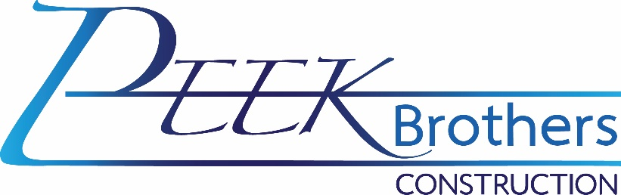

Heavy Equipment Field Mechanic– Full Time
The ideal candidate must be punctual, motivated, and willing to learn and develop their skills. Must also be detail-oriented, honest, and carry out tasks safely and professionally.
Heavy equipment mechanic performs Journeyman Level maintenance, diagnosis, and repairs. Must have the knowledge to cover a wide range of construction equipment. This position requires working independently in performing repairs and maintenance, including a solid understanding of hydraulics and electronics. Individuals should also have solid diagnostic and repair skills.
Qualifications:
- Must be able to pass a pre-employment drug screen.
- Two years of technical school, trade school, equivalent military training, and four years of hands-on experience in a heavy equipment maintenance/repair organization.
- Must have own hand tools.
- Functional knowledge of and ability to perform hands-on, in-depth diagnostics, electronic repair, mechanical repair, and fabrication on systems common to automobiles, heavy trucks, heavy equipment, and other miscellaneous vehicles and equipment.
- Will need to work independently to accomplish tasks.
- Has the aptitude to follow manufacturer recommendations and procedures.
- Need the necessary computer skills to operate various computer equipment and applications.
- Safely operate a variety of vehicles, maintenance, and repair equipment.
- Display an attitude of cooperation and work harmoniously with all levels of employees and the management.
- Communicate effectively in the English language at a level necessary for efficient job performance.
- Complete assignments in a timely fashion.
- Understand and comply with all rules, policies, and regulations.
- Maintain prompt and regular attendance.
- Perform all essential and marginal functions assigned by an authorized employee, supervisor, or Manager with or without reasonable accommodation.
- Position requires Class A or B Commercial Driver's License (CDL) with air brake, tanker, and combination endorsement; Mobile Air Conditioning Society (MACS) license for A/C recovery, recycling, and recharge.
- Individuals must be capable of operating vehicles and heavy equipment safely and have an acceptable driving record.
- Two years' service truck experience preferred.
Preferred Qualifications:
- 5+ years of hands-on combined experience in a heavy equipment maintenance/repair program.
- 3+ years of field service truck experience.
- Welder certification

Duties and responsibilities:
- Diagnose and repair all types of gas and diesel equipment, including, but not limited to, excavators, dozers, wheel loaders, water & lube trucks, service trucks, pickups, and other support equipment.
- Troubleshoot, repair, and replace the ignition, fuel, hydraulic, lighting, electrical/computer control systems.
- Repair/rebuild engines, transmissions, differentials, hydraulic cylinders, axle groups, etc.
- Perform welding and fabrication on mobile and stationary equipment as needed.
- Maintain service, maintenance, and repair records.
- Repair and maintain tools and machinery.
- Prepare work orders and order parts.
- Make emergency field repairs to on-site mobile equipment, as necessary.
- Safely perform repairs in the field during inclement weather.
- Other duties as assigned.

Physical requirements:
- Must be able to perform the above for at least 8 hours per day, five days per week. May be required to work over-time, after-hours, on weekends, for emergencies, or on-call.
- Ability to work while wearing safety boots, safety glasses, and hardhat when required.
- Ability to work in adverse weather conditions, which can include but is not limited to extreme heat and cold temperatures, inclement weather such as wind, rain, snow, sleet, and dust, and adverse driving conditions including wet roads, icy roads, and fog.
- Employees in this job classification may be exposed to dust, fumes, or other airborne pathogens.
- Must be able to lift/carry 50 lbs. on occasion and up to 100 LBS as needed with or without assistance.
Benefits:
- Competitive pay.
- Fully paid medical insurance for the employee, 50% paid medical for family.
- Vision and dental insurance available.
- 401K with up to 4% matching.
- Paid weekly
- Paid Time Off

